A Comparative Analysis of Usability and Engagement In Static versus Animated Dashboard Interfaces

Mariah Buhagiar
Institute of Information Communication and Technology
Malta College of Arts, Science & Technology
Paola, Malta
mariah.buhagiar.g52824@mcast.edu.mt

Abstract - This study examines how animation impacts perceived usability, engagement, and overall user experience by comparing static vs animated financial dashboard interfaces. Six participants carried out tasks and engaged with both dashboard versions. Semi-structured interviews and observation were used to gather data, which was then analysed using thematic analysis. The results showed that while the animated dashboard was thought to be more interesting and visually appealing, the static dashboard was shown to be clearer and easier to focus on. Overall, animation enhanced visual engagement but also distracted some participants during analytical tasks, which confirmed the hypothesis stated.
Keywords -Static dashboard, animated dashboard, usability, engagement, user experience, financial dashboard, HCI

- INTRODUCTION
This study compares static and animated financial dashboard interfaces to explore how animation affects perceived usability, engagement, and user experience. While animation can make dashboards feel more modern and engaging, it may also distract users during data interpretation tasks. The research examines whether animation supports or distracts users when interacting with dashboard information.

Description of Theme and Topic Rationale
Dashboards have become widely used tools for presenting large and complex datasets, offering users a curated overview of the most relevant information across many domains, including business, public health, learning analytics, personal analytics, and finance [1]. This study will focus on financial dashboard interfaces, and within financial services, the demand for efficient and intuitive digital experiences is especially important, as users need interfaces that help them understand and engage with personal financial information more effectively [2]. As dashboard design becomes more sophisticated, features such as interaction, components, and visual presentation play an increasing role in shaping the overall experience [3].
At the same time, interface research shows that usability and user experience are strongly influenced by interface layout, information quality, and interaction logic [3]. Studies comparing static and dynamic visual formats also suggest that different presentation styles can shape how clearly information is communicated and how engaging it appears to users [4]. Therefore, this study explores how static and animated dashboard interfaces influence perceived usability and engagement within a financial dashboard context.

Positioning and Research Onion
This study explores Human–Computer Interaction (HCI), focusing on how dashboard design influences user experience. It specifically examines whether animation affects perceived usability and engagement, with an emphasis on subjective user perceptions rather than performance metrics.
To guide the methodology, Saunders et al.’s Research Onion framework is used to structure and justify the research design. The following sections explain each layer of the study, as illustrated in Figure 1.

Research Philosophy
This research follows an interpretivist philosophy, focusing on how individuals interpret and experience interface design. It is appropriate as the study explores users’ perceptions of usability and engagement when interacting with static and animated dashboard interfaces, rather than relying on numerical data.
Research Approach
An inductive approach is adopted, allowing themes related to usability, engagement, and visual clarity to emerge from participants’ observations and feedback.
Research Strategy
The study uses an experimental strategy, comparing static and animated dashboard interfaces. This enables a direct evaluation of how animation influences user interaction and overall experience.
Research Choice
A mono-method qualitative approach is used, relying on data collected through observation and semi-structured interviews.
Time Horizon
The study follows a cross-sectional time horizon, with data collected during a single session where participants interact with both dashboard versions.
Techniques and Procedures
Data is collected through observation and semi-structured interviews. Observation captures user behaviour and interaction patterns, while interviews provide deeper insight into users’ perceptions of usability, engagement, and visual clarity.
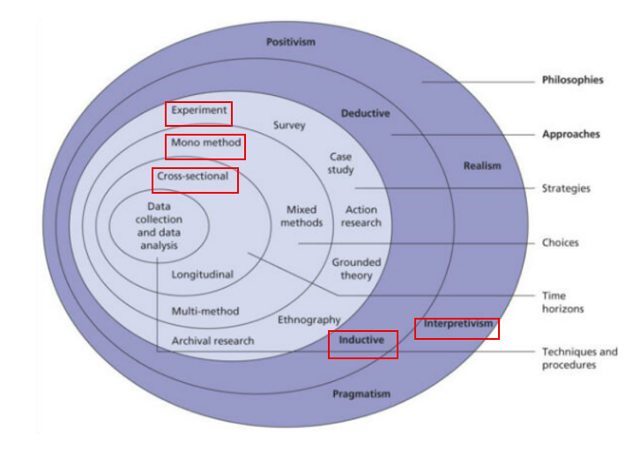
Figure 1: Research Onion Diagram

Background of this Research Theme
Dashboards are widely used to present complex information in a structured and visually accessible way, helping users identify trends, monitor key indicators, and interpret data more efficiently [1]. In financial contexts, dashboards are especially useful because they allow users to track and understand personal financial information through visual summaries [2].
As interface design has evolved, dashboards have increasingly included dynamic and interactive elements. Research shows that interface layout, interaction logic, and visual feedback can influence both usability and overall user experience [3]. However, studies comparing static and dynamic visual formats suggest that motion can improve engagement in some cases, while also making information harder to interpret in others [4].
For this reason, animation in dashboard design remains an important area of study. This research contributes to that discussion by examining how users perceive static and animated dashboards in terms of usability and engagement.

Hypothesis
Animation in Dashboards enhances visual interest but interferes with focus during analytical tasks

Research Aim and Purpose statement
The aim of this research is to investigate how animation influences user perceptions of usability and engagement in dashboard interfaces.

The purpose of this qualitative comparative study is to explore the influence of animation on perceived usability and engagement in financial dashboard interfaces for participants familiar with digital interfaces in a controlled usability testing setting.

Literature Review

Introduction to the Research Area
This review examines how previous researchers have studied dashboards, user experience, and animated or static visual designs to identify common research strategies, key elements, and gaps. The studies referenced provide an understanding of how dashboard interfaces are designed, how usability and engagement are evaluated, and how animation may influence user perception.

Dashboard Design and Structural Approaches
A foundational approach to dashboard research is presented by Bach et al. [1], who analyse dashboards by identifying design patterns. Their study examines a large set of dashboards and categorises structures that occur repeatedly, layouts, and interaction components. This methodology is analytical and design-focused, aiming to understand how dashboards are typically constructed rather than how they are experienced by users. The strength of this approach is in its ability to reveal common design practices and highlight how different visual and functional elements are combined to support data presentation. By identifying patterns such as the structure of the layout, filtering, and visual hierarchies, Bach et al. [1] provide a strong theoretical foundation for dashboard design. However, the limitation of this method is that it does not involve user testing or direct interaction with participants. As a result, while it explains how dashboards are built, it does not address how users perceive usability or engagement, leaving a gap between design structure and user experience.

User-Centred Dashboard Evaluation
Young and Kitchen [5] provide a more user-focused methodological perspective, who explore dashboard design from the perspective and view of the audience. Their research adopts a user-centred approach, collecting qualitative feedback to understand how individuals interpret and interact with dashboards. This method is valuable because it recognises that dashboards are not only visual systems but also communication tools that must be understood by users. Young and Kitchin [5] use their findings to create design guidelines derived from real user experiences, highlighting factors such as clarity, accessibility, and interpretability. This approach contrasts with the design-driven method of Bach et al. [1], as it prioritises how users make sense of information rather than how it is structured. However, although this study provides important insight into usability and interpretation, it does not examine animation. The focus remains on general dashboard design principles, which means that the impact of animated versus static interfaces is not directly addressed.

Comparative Usability and Interface Evaluation
Comparative methodologies are demonstrated in the work of Wang et al. [3], who study usability and user experience in the context of interface design software. Their research compares multiple systems based on factors such as interface layout, interaction logic, and usability. This approach is useful because it allows for an evaluation of different design alternatives, making it possible to identify strengths and weaknesses across systems. Wang et al. [3] show that usability can be assessed through structured comparison, where different interface conditions are analysed using consistent criteria. This is extremely relevant to the current research, which also involves comparing two interface types. The strength of this methodology is its ability to highlight differences between designs in a clear and systematic way. However, the limitation is that their study is focused on design software rather than dashboards.

Static vs Dynamic Visual Presentation
The comparison between static and dynamic visual formats is explored more in the study by Shemy [4], who examines digital infographics. This research adopts an experimental approach, comparing static and dynamic formats to assess and evaluate how visual presentation affects users. Shemy [4] demonstrates that the format in which information is presented can influence how it is processed and understood, suggesting that motion can play a significant role in shaping user response. This is extremely relevant to the study, as it supports the idea that animation may affect usability and engagement. The strength of Shemy’s [4] study comes from its focus on isolating visual format and allowing for a clear comparison between static and dynamic conditions. However, infographics differ from dashboards, since infographics are typically designed for presentation and storytelling, whereas dashboards are interactive systems used for monitoring and analysis [4,1].

Animation and User Perception in Interfaces
Further insight into animation is provided by Ge et al. [6], who examine how users perceive animation in interface transitions. Their study focuses on the timing and smoothness of animated transitions, showing that different durations can influence how users experience interaction within an application. This research highlights that animation is not simply a visual addition, but a factor that can shape user perception and interaction. Ge et al. [6] demonstrate that poorly designed animation can negatively affect user experience, while well-timed transitions can improve the smoothness and usability of an interface. This is highly relevant to the current research, as it suggests that the impact of animation depends not only on its presence but also on how it is implemented. However, the study focuses on animation fluency rather than dashboard-specific tasks, meaning that its findings must be considered within the broader context of interface interaction.

Testing Strategies in Existing Research
The testing strategies used in these studies also vary depending on their research focus. Bach et al. [1] use analytical classification to identify patterns, which provides a broad understanding of dashboard design but does not include user interaction. Young and Kitchin [5] rely on qualitative user feedback, allowing them to explore how dashboards are experienced in practice. Wang et al. [3] use comparative testing to evaluate differences between interface designs, while Shemy [4] applies an experimental comparison to isolate the effects of static and dynamic presentation. Ge et al. [6] use controlled testing to examine how animation timing influences user perception. These strategies show that interface research often combines design analysis, user-centred evaluation, and controlled comparison to understand how different design choices affect user experience.

Research Gaps
Despite the valuable contributions of these studies, several gaps still remain. Bach et al. [1] provide a strong understanding of dashboard design patterns, but do not address user perception. Young and Kitchin [5] explore usability and interpretation but do not examine animation. Wang et al. [3] offer a comparative methodology but in a different context, while Shemy [4] studies static and dynamic visuals outside of dashboard environments. Ge et al. [6] focus on animation fluency but do not link this directly to dashboard usability or engagement. This reveals a clear gap in the literature, as there is limited research that combines dashboard design, animation, usability, and engagement within a single study.

In conclusion, the reviewed literature demonstrates that a range of research methodologies have been used to study interface design. Each study provides an insight into different aspects of design and user experience, but none fully integrates the effects of animation within dashboard interfaces. Therefore, this current study aims to address this gap by comparing static and animated dashboard interfaces and exploring how these design choices influence user perception, usability, and engagement.

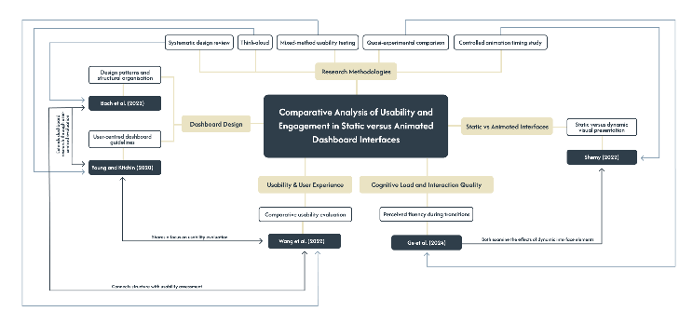
Figure 2: Literature Map

Research Methodology
This section outlines the research methodology used to investigate how static and animated dashboard interfaces influence user perceptions of usability and engagement, supporting the study’s aim and hypothesis.

Research Questions
1. How do static and animated dashboard interfaces differ in terms of usability?
2. How do static and animated dashboard interfaces differ in terms of user engagement?
3. To what extent does animation improve or hinder the overall user experience of dashboard interfaces?
Research Objectives
1. Design two dashboard interface versions, one static and one animated, with similar layout, content, and structure.
2. Test both dashboard versions with participants in order to compare their usability and engagement.
3. Collect user feedback and interaction data relating to clarity, ease of use, visual appeal, and overall experience conducted from an interview.
4. Analyse whether animation contributes positively or negatively to the interface experience through thematic analysis.
5. Identify design implications for future dashboard development based on the findings.
Research Philosophy
This study follows an interpretivist philosophy, focusing on how participants perceive and interpret static and animated dashboard interfaces. This approach is appropriate as the research aims to explore subjective experiences of usability and engagement rather than relying solely on objective measurements, which aligns with user-centred perspectives in interface research [5].
An inductive approach is adopted, allowing themes related to usability, engagement, and visual clarity to emerge from qualitative data collected through observation and interviews. This reflects approaches used in interface and visual studies where user interpretation and experience are central to understanding design effectiveness [4].
Overall, the study is positioned within a qualitative, interpretive paradigm with a comparative focus, examining differences between static and animated interface designs and how these influence user perception [4], [5].
Chosen Methodology
The most suitable methodology for this research is a mono-method qualitative comparative study using observation and semi-structured interviews. This is appropriate because the study aims to explore users’ experiences in depth rather than measure them only through scores.
The literature supports this choice, Young and Kitchin [5] are the strongest influence because they show the value of exploring dashboards through direct user interaction and qualitative insight. Bach et al. [1] provide a useful understanding of dashboard structure, while Wang et al. [3] demonstrate the importance of comparison in usability research. Shemy [4] and Ge et al. [6] further support the relevance of comparing static and dynamic interface elements. Together, these studies suggest that comparison is important, and that user interpretation is equally important.
Description of the Chosen Research Methodology
The study compared two dashboard interfaces: one static and one animated. Both versions were designed based on established dashboard design principles, particularly those identified by Bach et al. [1], to ensure that layout, structure, and content remained consistent. This was important as prior research shows that dashboard composition and visual hierarchy strongly influence user understanding and interaction [1], [5].
A total of 6 participants were selected using a convenience sampling approach, consisting of individuals familiar with general digital interfaces. Participants were divided into two groups to reduce order bias. One group interacted with the static dashboard first followed by the animated version, while the second group followed the reverse order. This approach ensured that the sequence of exposure did not influence the results.
Participants interacted with both dashboard versions during a single session and completed a set of predefined tasks, such as identifying spending trends, locating key information, and adding a scheduled purchase. During this process, observational data was collected through field notes, where user behaviour, hesitation, navigation patterns, and visible confusion or ease of use were recorded. This method allowed for the capture of real-time interaction patterns, which are often not expressed verbally.
Following the interaction phase, semi-structured interviews were conducted to explore participants’ perceptions of usability, engagement, clarity, and overall preference. This combination of observation and interviews reflects a user-centred approach, as highlighted by Young and Kitchin [5], where both behaviour and subjective interpretation are considered. It also acknowledges the role of visual presentation and animation in shaping user experience, as discussed by Shemy [4] and Ge et al. [6].

Reflections on Validity, Reliability and Generalisability
Validity in this study depends on ensuring that the two dashboard versions differ only in animation, while all other design elements such as layout, content, and structure remain consistent. This is important because previous research shows that interface structure and visual presentation strongly influence how users interpret information [1], [5]. If additional variables are introduced, it becomes difficult to determine whether user responses are caused by animation or other design differences. To strengthen validity, the study applies triangulation by combining data from observation and semi-structured interviews, allowing user behaviour and perceptions to be examined from multiple perspectives [5].
Reliability in qualitative research is more complex, as participants may interpret and respond differently. However, consistency is supported by using the same tasks, observation procedures, and interview questions across all participants. In addition, member checking is used to confirm that participants’ responses are accurately understood, ensuring that the findings reflect their intended meaning [4]. An audit trail is also maintained to document the research process and analytical decisions, improving transparency.
The findings of this study are unlikely to be statistically generalisable due to the small sample size and qualitative nature of the research. However, they may provide transferable insights for similar dashboard design contexts. This aligns with the context-specific nature of interface research, where user perception is shaped by design and presentation factors [4]–[6].
Ethical Considerations
Although the study is low risk, ethical issues still need to be considered. Participants must give informed consent and understand the purpose of the study, what they will do, and that participation is voluntary. Due to the fact that observation and interviews are used, participants should know that their behaviours and responses will be part of the research data [5].
Confidentiality must also be protected, therefore any notes, recordings, or transcripts are anonymised and stored securely for academic use only and deleted once the project is done.
A further ethical issue is participant comfort. Since the research compares static and animated interfaces, some users may find animation distracting or tiring. This concern is supported by Shemy [4] and Ge et al. [6], who both show that dynamic visuals can affect cognitive experience and perceived fluency. For this reason, the animated version should be designed carefully, and participants should be free to stop or withdraw at any time.

- RESULTS, ANALYSIS & DISCUSSION
Thematic Analysis Process
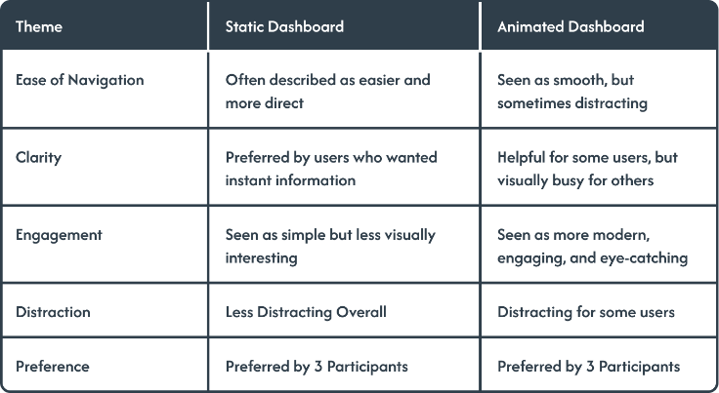
The interview and observation data were analysed using thematic analysis. Participants were divided into two groups to reduce order bias, meaning that some participants tested the static dashboard first while others tested the animated version first. Participant responses were also reviewed to identify repeated ideas, which were then coded and grouped into final themes. The main themes identified were ease of navigation, clarity, engagement, distraction, and preference. Table 1 shows how selected interview comments were transformed into initial codes and then grouped into final themes.
Coding of Participant Responses
The coding process demonstrates how the qualitative data was organised according to recurring meanings rather than isolated individual responses. For example, comments about information appearing instantly were coded as instant access to information and grouped under the theme of clarity. Similarly, comments about movement helping participants understand the data were coded as animation supports interpretation and grouped under engagement. This process made it possible to compare how participants experienced the static and animated dashboard versions.
Static Dashboard Findings
Table 2 shows that the static dashboard was mainly associated with clarity, direct navigation, and reduced distraction. Participants who preferred the static version explained that it allowed them to focus on the financial information without additional movement. This suggests that the static dashboard supported users who valued quick access to information and a more straightforward interface.
Animated Dashboard Findings
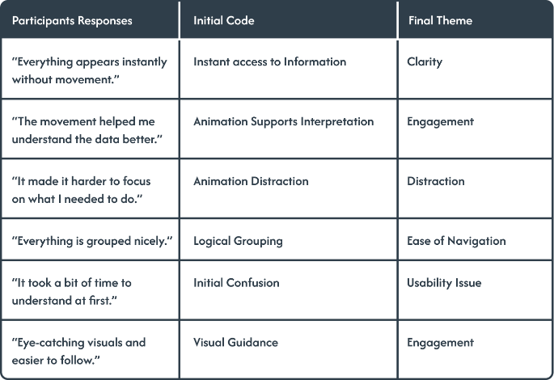
In contrast, the animated dashboard was associated with engagement, visual appeal, and attention guidance. Some participants felt that the movement helped them follow the information more easily and made the dashboard feel more modern and interactive. However, not all participants responded positively to the animations. For some users, the movement made the interface feel busier and slightly harder to focus on.
Relationship to the Hypothesis
Overall, the findings partially support the hypothesis. The animated dashboard was perceived as more engaging and visually interesting, but it was not consistently considered easier to use. The static dashboard was preferred by participants who valued simplicity, clarity, and fast access to information, while the animated dashboard was preferred by participants who responded positively to visual feedback and motion.
Limitations and Transferability
Due to the small qualitative sample, the findings are not statistically generalisable. However, they provide useful transferable insights for similar dashboard design contexts. The results suggest that animation should be used carefully and purposefully in dashboard interfaces, as it can improve engagement but may reduce clarity if it becomes distracting.

- CONCLUSION
This research compared static and animated dashboard interfaces to explore how animation influenced usability, engagement, and overall user experience. The findings showed that the static dashboard was generally perceived as clearer and easier to focus on, while the animated dashboard was viewed as more engaging and visually appealing.
In relation to the first research question, the static dashboard appeared to support usability more effectively for participants who valued direct access to information and minimal distraction. For the second research question, the animated dashboard was stronger in terms of engagement, as several participants described it as more modern, interactive, and eye-catching. For the third research question, animation both improved and hindered the user experience. It improved the experience by increasing visual interest and helping some users follow information more easily, but it also hindered the experience for others by making the interface feel busier and harder to focus on.
Overall, the hypothesis was partially supported. Animation did enhance visual interest, but it also interfered with focus for some participants during analytical tasks. This suggests that animation should not be used only for decoration. Instead, it should be applied carefully and purposefully to support attention without reducing clarity.
A limitation of this study is the small sample size of six participants, meaning that the findings cannot be statistically generalised. The study also relied on qualitative observation and interviews, which means responses were based on participant perception and interpretation. Another limitation is that the testing took place in a short single-session format, so it did not examine long-term use of the dashboard.
Future research could involve a larger participant sample and include quantitative measures such as task completion time, error rate, or SUS scores. Further studies could also compare different types of animation, such as subtle transitions, chart animations, and attention cues, to identify which forms of motion best support usability and engagement in dashboard interfaces.

REFERENCES
[1] B. Bach et al., “Dashboard Design Patterns,” IEEE Transactions on Visualization and Computer Graphics, vol. 29, no. 1, pp. 1–11, 2022, doi: https://doi.org/10.1109/tvcg.2022.3209448.
[2] “Designing for User Engagement among Young Adults: Applying Design Thinking to develop a Financial Dashboard.” Available: https://www.diva-portal.org/smash/get/diva2:1788177/FULLTEXT01.pdf
[3] J. Wang, Z. Xu, X. Wang, and J. Lu, “A Comparative Research on Usability and User Experience of User Interface Design Software,” International Journal of Advanced Computer Science and Applications, vol. 13, no. 8, 2022, doi: https://doi.org/10.14569/ijacsa.2022.0130804.
[4] N. S. Shemy, “Digital Infographics Design (Static vs Dynamic): Its Effects on Developing Thinking and Cognitive Load Reduction,” International Journal of Learning, Teaching and Educational Research, vol. 21, no. 5, pp. 104–125, May 2022, doi: https://doi.org/10.26803/ijlter.21.5.6.
[5] G. W. Young and R. Kitchin, “Creating design guidelines for building city dashboards from a user’s perspectives,” International Journal of Human-Computer Studies, vol. 140, p. 102429, Aug. 2020, doi: https://doi.org/10.1016/j.ijhcs.2020.102429.
[6] Y. Ge, H. Chen, Y. Wang, W. Qu, Y. Zhang, and Y. Liu, “User perception of animation fluency: The effect of time duration in different phases of animated transitions during application usage,” International Journal of Human-Computer Studies, vol. 186, pp. 103257–103257, Jun. 2024, doi: https://doi.org/10.1016/j.ijhcs.2024.103257.

